Style Guide

Components

header

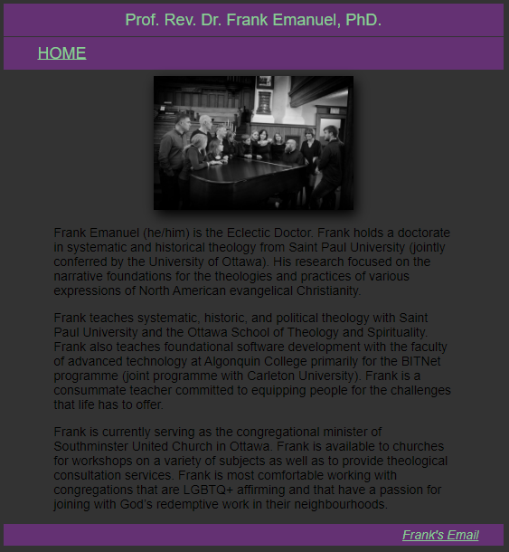

footer

main

navigation bar

*description of each component*

Colours

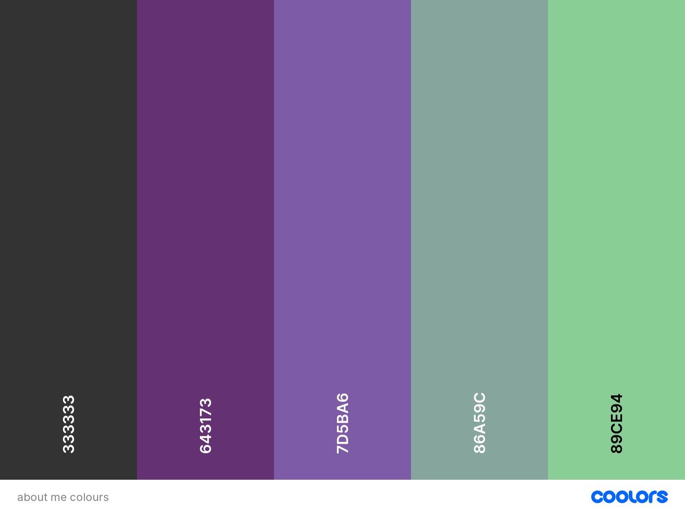

*List what each colour is used for (foreground, background, alternate background, accent, links, etc.)*

Typography

Sans-serif font (Arial family) with a Roboto font for accents.

*describe what fonts are used where*